

AuScope Discovery Portal User Guide

AuScope LtD. |  email: cg-admin#csiro.au | [www.auscope.org.au](http://www.auscope.org.au) | July 2024

AuScope Discovery Portal User Guide

Contents

Table of Figures 3

Overview 5

Data Services 6

Information Panel 6

Browse Panel 7

Active Layers Panel 9

Status Panel 11

Displaying Map Legend 12

Information Panel 13

Downloading from the Active Layers Panel 14

Selecting a bounding box to limit the download size 15

Layer Styling in Active Layers Panel 17

Wildcards 18

Search and Download Bar 19

Downloading Data with the Search Panel 21

Map 22

Map Navigation 23

Split View 24

Map Projection 25

Changing the default ESRI World Imagery base map 25

Polygon Filter 26

Custom layers 27

Custom URL 27

Custom File 28

Create a Shareable and Citable Reference 29

When not logged in 29

When logged in 29

Login and Bookmarks 30

Managing ROIs and Permanent Links 32

Managing ROIs 32

Managing Access to Shareable URLs 32

Logout 34

Example 1: NVCL Boreholes 35

NVCL Boreholes: Steps 1, 2, 3 and 4 36

NVCL Boreholes: Step 6 37

NVCL Boreholes: Step 7 38

NVCL Boreholes: Step 8 39

NVCL Borehole Service View 39

NVCL Boreholes: Steps 9 and 10 41

Example 2: Download an NVCL TSG Dataset 43

Example 3: Filter By Geological Province 46

Steps 1, 2 & 3: Filtering by name, add geological province layer. 46

Step 4: Copying to clipboard. 48

Step 5: Add NVCL borehole layer. 49

Glossary 51

# Table of Figures

Figure 1: AuScope Portal with ESRI National Geographic base map. 5

Figure 2: Information Panel 6

Figure 3: Browse Panel 7

Figure 4: Active Layer controls. 9

Figure 5: Toggle for opening and closing Active Layers panel. 10

Figure 6: Example Status Panel 11

Figure 7: Example Legend 12

Figure 8: Information Panel 13

Figure 9: Two different modes of download Panel. On the left is before selecting a download area, on the right is after area selection. 14

Figure 10: Selecting a bounding box to limit the download size. 15

Figure 11: Download Panel with bounding box filter. 16

Figure 12: Filter Settings 18

Figure 13: Advanced Option Toolbar 19

Figure 14: Advanced Option: change the fields that are searched. 19

Figure 15: Advanced Option: Change the type of services searched for 20

Figure 16: Advanced Option: Area search criteria. 20

Figure 17: Search and Download Bar 21

Figure 18: Map of Australia with default “ESRI World Imagery” base map. 22

Figure 19: Using the magnify button to zoom to a certain area on the map (ESRI National Geographic) 23

Figure 20: Comparing borehole layers using the split view and the “Left”, “Right” and “Both” buttons. 24

Figure 21: Selecting map projection. 25

Figure 22: Background map selection. 25

Figure 23: Polygon Filter 26

Figure 24: Custom layers. 27

Figure 25: Load a KML or KMZ file onto map. 28

Figure 26: Creating a permanent link when not logged in. 29

Figure 27: Create a permanent link when logged in. 29

Figure 28: The location of the login button. 30

Figure 29: Layers can be bookmarked. 30

Figure 30: Layers in "ASTER Mineral Maps" have been bookmarked. 31

Figure 31: Managing ROIs and Permanent Links 32

Figure 32: Managing Regions of Interest (ROI) 32

Figure 33: Managing Permanent Links 33

Figure 34: Example core sample. 35

Figure 35: NVCL Boreholes: Steps 1, 2, 3 and 4 36

Figure 36: NVCL Boreholes: Step 6: Select a borehole. 37

Figure 37: NVCL Boreholes: Step 7: click on Image tab. 38

Figure 38: NVCL Boreholes: Step 7: Click Scalar tab. 39

Figure 39: NVCL Borehole Service View 40

Figure 40: NVCL Borehole Service detailed image and spectral data plots. 40

Figure 41: NVCL Boreholes: Steps 9 and 10 41

Figure 42: Depth and sample count at a point. 41

Figure 43: NVCL Boreholes: Graph of borehole minerals. 42

Figure 44: NVCL Boreholes: Details of graph controls. 43

Figure 45: Click on "Download" tab. 44

Figure 46: Click on Prepare Tsg Dataset button. 45

Figure 47: Step 1: Add geological province layer. 46

Figure 48: Step 2: Filter by name: "Yilgarn.” 47

Figure 49: Step 4: Click on “Copy to Clipboard.” 48

Figure 50: Step 5 & 6, National Virtual Core Library V2.0” layer and filter by geological province. 49

# Overview

The AuScope Discovery Portal <https://portal.auscope.org.au/> displays geospatial data obtained from a number of geoscience organisations around Australia. The portal provides a way to find and download geospatial data and display it on the map. Finding the data is managed by the *data services* panels at the left-hand side, and the new search bar at the top.

The following sections describe the portal: the first section of this document is an overview of the portal data services. Later sections provide details on the portal's operations. The examples section contains steps to perform common activities.

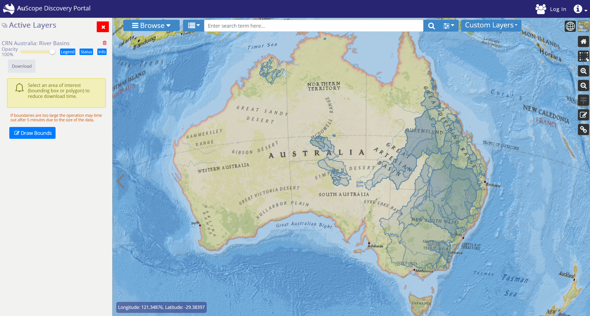

Figure 1: AuScope Portal with ESRI National Geographic base map.

# Data Services

The data services are a collection of web-based services from organisations around Australia that provide geospatial data, such as Geoscience Australia, CSIRO, state governments geological surveys and several Australian universities.

Various organisations provide data to the portal: it may be as simple as satellite imagery or a view into a geospatial database. The data provided by these services are drawn as *layers* overlaying the background map. Selecting the data to view can be done in two different ways:

1. “Browse Panel” will allow you to choose from a curated menu of layers grouped into categories. These layer categories are known as “Featured Layers Groups.”
2. “Search Panel” can be used to search from a large variety of layers by entering a search term into a text box.

# Information Panel

By clicking on the  button at the far top right corner of the window, information about this website and also this User Guide can be accessed, see Figure 2.

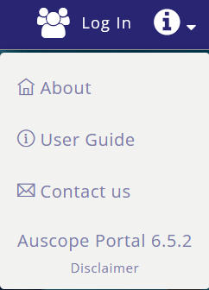

Figure 2: Information Panel

# Browse Panel

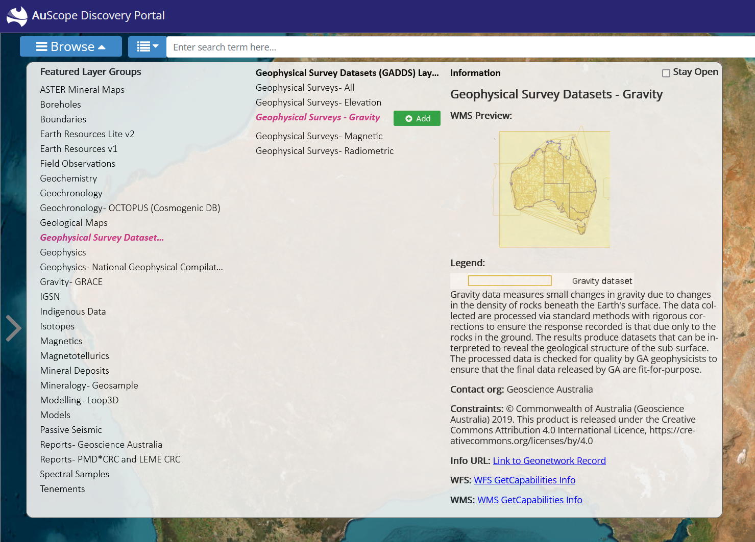

Figure 3: Browse Panel

To view a layer, you have to:

1. Click on  at the top left-hand corner of the screen. (Figure 3)
2. Select a category in the “Featured Layer Groups” column on the left-hand side.
3. Select a layer from the middle column, by clicking on the layer name.
4. The right-hand column will be updated with information about the layer.
5. Add the data as a map layer by clicking on **Add Layer** button in the right-hand column.
6. The “Browse Panel” will close when you add the layer. To disable this, you can select the “Stay Open” tickbox at the top right corner of the “Browse Panel.”
7. On the far-left hand side the “Active Layers” panel will appear. This can be used to modify the layer.

Note that adding a layer may not display the data immediately: the data has to be fetched from the providers and so it may take a few minutes and be displayed in batches.

# Active Layers Panel

The Active Layers Panel appears when a new layer is loaded onto the map. The controls are described in Figure 4 below.

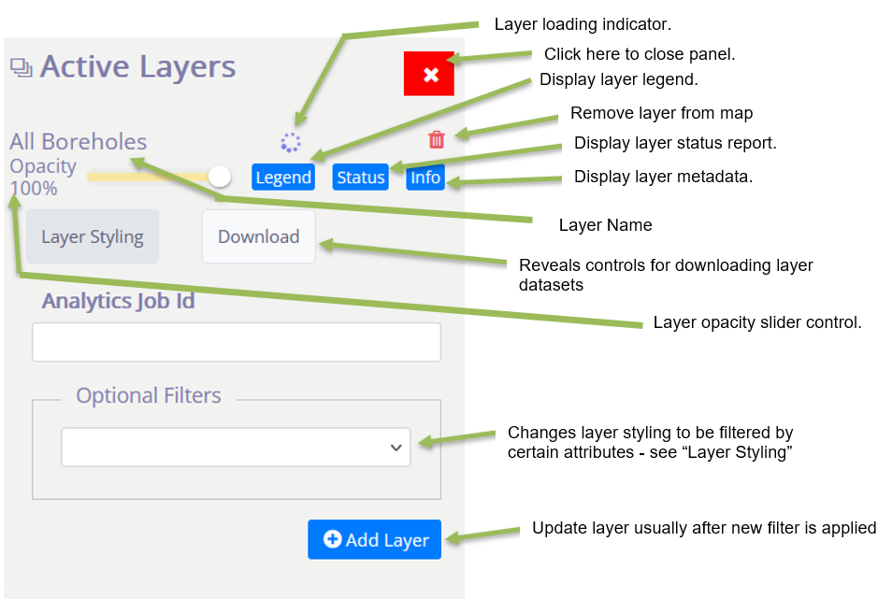

Figure 4: Active Layer controls.

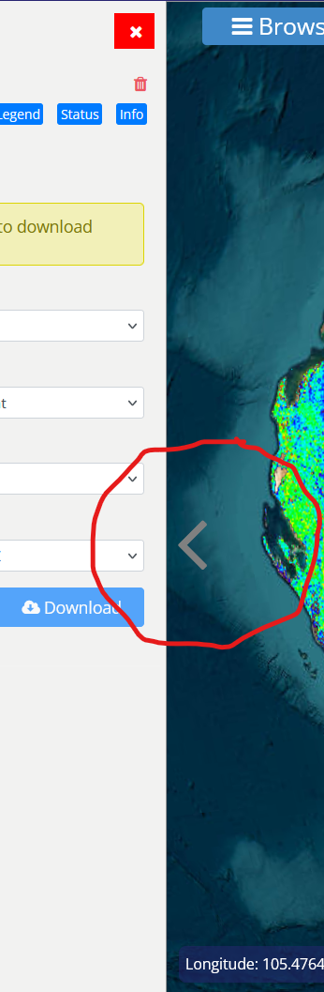

Figure 5: Toggle for opening and closing Active Layers panel.

To close “Active Layers” panel either:

1. Click on  at top right-hand corner of panel.
2. Click on “<” panel toggle, see Figure 5

To open “Active Layers, click on “>” panel toggle, see Figure 5

## Status Panel

To check on the progress of layers that are being loaded onto the map click  in the Active Layers panel to get a report. Figure 6 is an example.

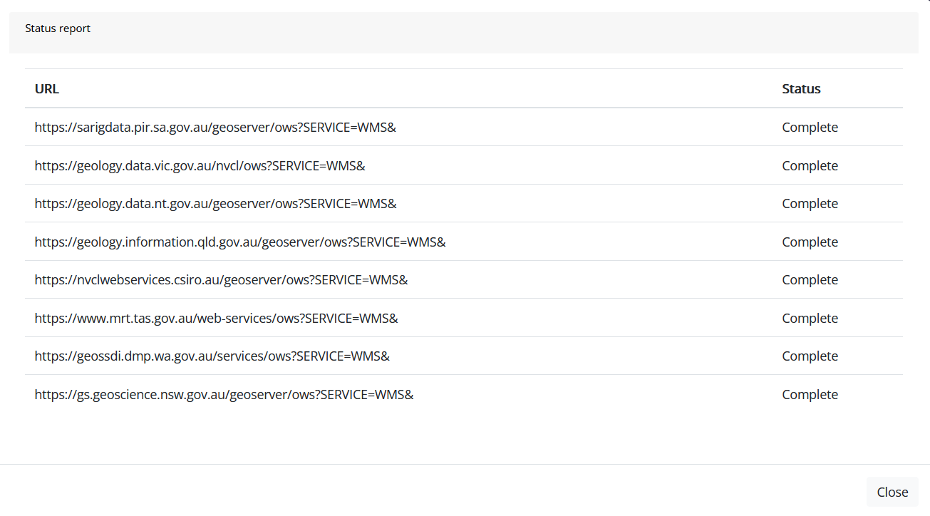

Figure 6: Example Status Panel

## Displaying Map Legend

Clicking on the  button in the Active Layers panel will display the Map Legend on the map. See Figure 7 for an example.

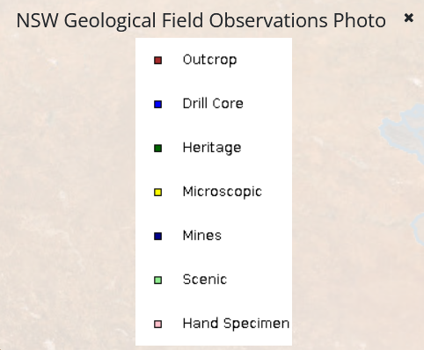

Figure 7: Example Legend

## Information Panel

Clicking on the  button in the Active Layers panel will open up the Information panel to find more detailed information about the layer. Click on the provider name to display service details.

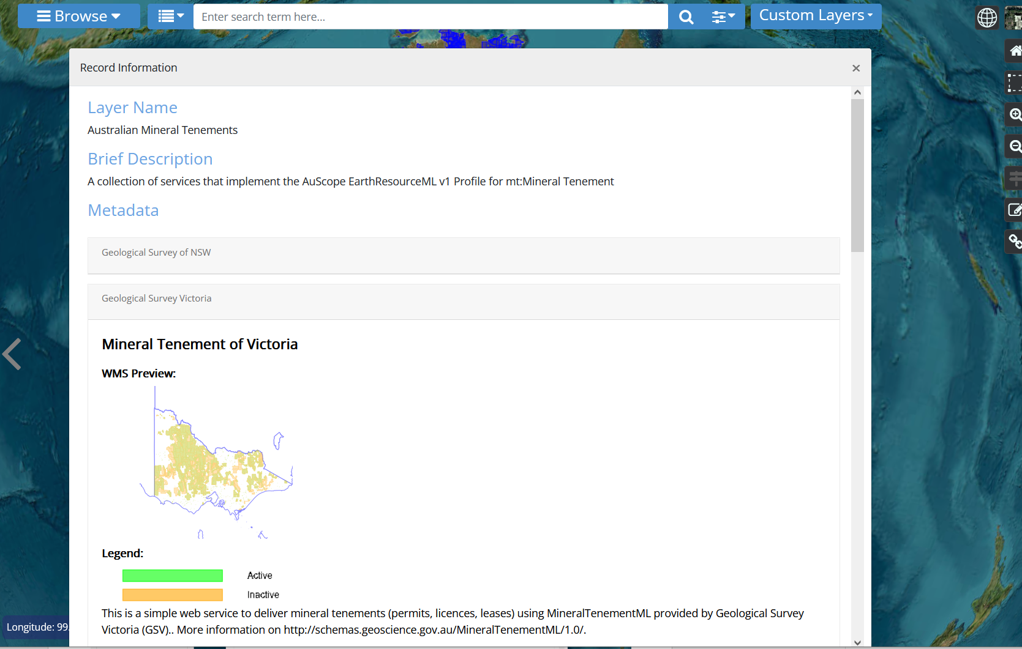

Figure 8: Information Panel

# Downloading from the Active Layers Panel

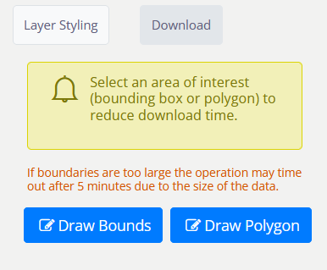 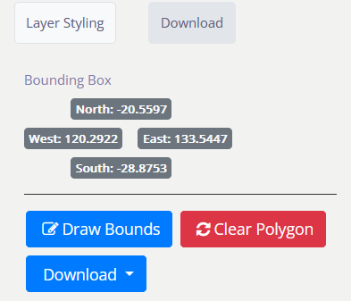

Figure 9: Two different modes of download Panel. On the left is before selecting a download area, on the right is after area selection.

If you would like to perform further analysis on the data being viewed in the portal, you can download the data to your workstation by selecting the **Download** Tab.

If you click on the **Download** button, you will download all the data from all providers. This request may fail if there is too much data, as the connection may time out.

It is therefore advisable to use the **Draw Bounds** or **Draw Polygon** (if available) buttons to reduce the size of the download request.

## Selecting a bounding box to limit the download size

If you click on the **Draw Bounds** button you can create a bounding box by clicking twice in the map area, once in the top left corner and again in the bottom right corner as shown above. Some layers will provide a **Draw Polygon** button that will allow you to draw a polygon to define download bounds.

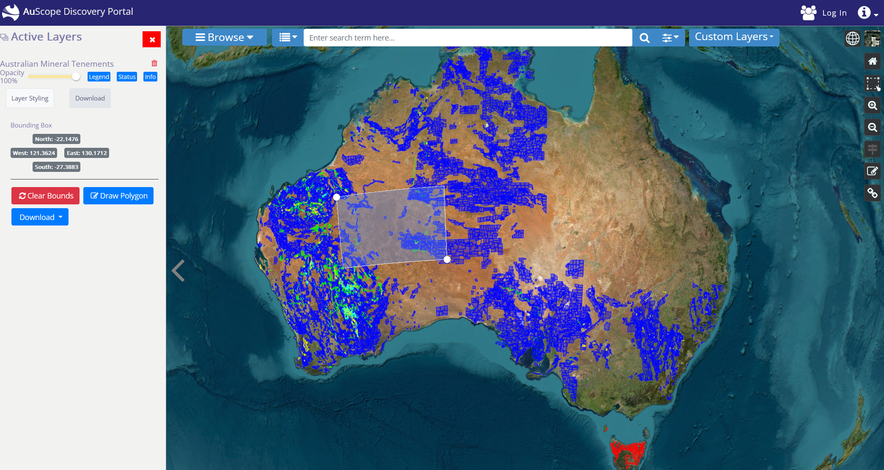

Figure 10: Selecting a bounding box to limit the download size.

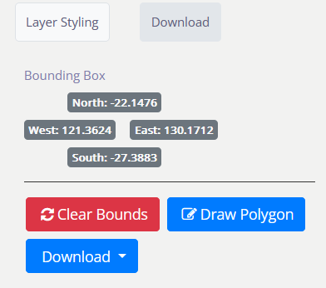

Figure 11: Download Panel with bounding box filter.

Once a bounding box has been defined, the Download Panel will display its coordinates (above), and you can click on the **Download** button to get the results.

# Layer Styling in Active Layers Panel

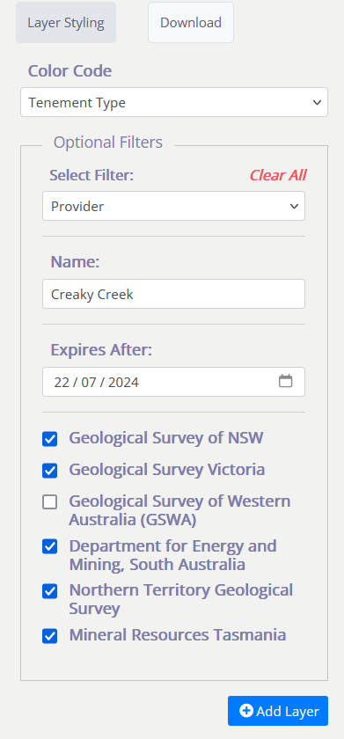

“Provider” filter limits the map to display certain states and territories

This “Expires After” filter will allow the map to display features whose expiry date is after the date below

This “Name” filter will allow the map to display features with a certain name

Click here to remove optional filters

Click here to create new filters

Mandatory filters are displayed here

Update layer usually after new filter is applied

Figure 12: Filter Settings

Each layer provides different ways to filter the data depending on the structure of its data. The following image shows a sample of the filters from three different mining layers. Note that each filter provides fields of several types: plain text, dates and select lists.

 Plain text fields match the data exactly, but case insensitive. Some data services also support wildcards to match portions of the field.

 Date fields are in the format: “yyyy-mm-dd” and also provide a pop-up calendar to select the date (invalid dates are indicated with a red border around the input text box).

 Select lists are populated from unique values from the data.

Some layers may not have any filters. Layers that supply imagery may only provide a filter to change the layer's opacity when the images are drawn on the map.

Some layer fields are numeric, for example the amount of ore processed. There are no checks to verify that you have entered a numeric value in these fields. Entering a non-numeric value will result in either no data or the filter will be ignored.

Click the **Add layer to map** button to apply any filters to the data and display the results on the map. If the layer is already active it will be replaced by a layer with the new filter.

A number of data services provide data from external sources and when they are added to the map a copyright notice will be shown.

## Wildcards

Wildcards are special characters that allow filters to match all or part of a text field. They may also position the match at the beginning or end of the field.



A data provider may choose not to implement wildcards (for example, to reduce processing overheads) or limit their behaviour. This means a filter on a text field *may* accept any of these matching rules:

1. A strict match of the entire text field, usually case insensitive.
2. A match to any portion of the field. For example, a filter of "old" will match "goldfield lease" and "the folding chair".
3. A "match any" beginning/end wildcard (asterisk:)**. For example, "sil**" will match "silver mine" and "silicon chip". Similarly, "*ts" will match "hot spots" and "polar orbits".
4. A "single character" wildcard (Hash: #). For example, "*9#" will match "bore 295" and "mine number 1294".

# Search and Download Bar

Use the search bar at the top of the page to search for specific layers.

Enter a search term in the text field provided and press the search button  to conduct the search. You may also choose from one of the suggested terms as you type by clicking on it.  
  
If there are many results they can be viewed a page at a time via these buttons at the bottom left of the panel: 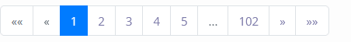

Layers labelled with  will appear at the top of the search results list. These layers are also accessible from the Browse Panel.

Press the Advanced Options button  to show the Advanced Option toolbar (Figure 13), which allow you to further refine your search to specific record fields, OGC services and spatial locations.  
  


Figure 13: Advanced Option Toolbar

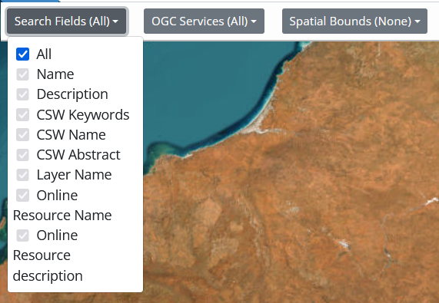

Figure 14: Advanced Option: change the fields that are searched.

In Figure 14 the fields within each record that are searched can be selected. By default, “All” fields are searched, but if the “All” is unticked, other services can be searched.

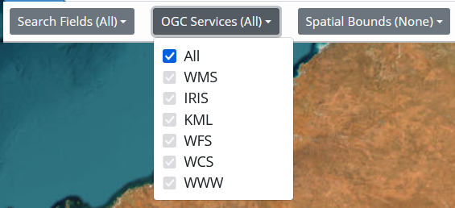

Figure 15: Advanced Option: Change the type of services searched for

In Figure 15 the type of services can be chosen. By default, “All” services are selected, but if the “All” is unticked, other services can be selected.

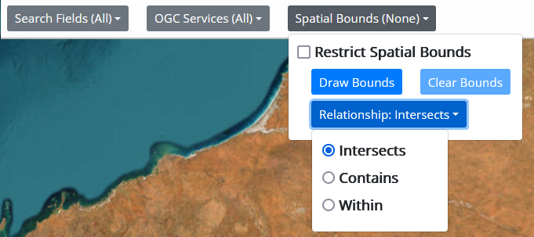

Figure 16: Advanced Option: Area search criteria.

In Figure 16 we see that one can search for records based on the area that they cover.

The user must draw a polygon using the “Draw Bounds” button.  
There are three kinds of spatial searches:

1. “Intersects” – all records that intersect with the drawn polygon.
2. “Contains” – all records that fully contain (i.e. envelop) the drawn polygon.
3. “Within” – all records that are completely within (i.e. inside) the drawn polygon

Layers in the list can be added to the map using button, if it is available. A pale  button indicates that this cannot be added to the map.

Results may automatically be hidden as you interact with the map, to reveal them again press the show/hide results button .

## Downloading Data with the Search Panel

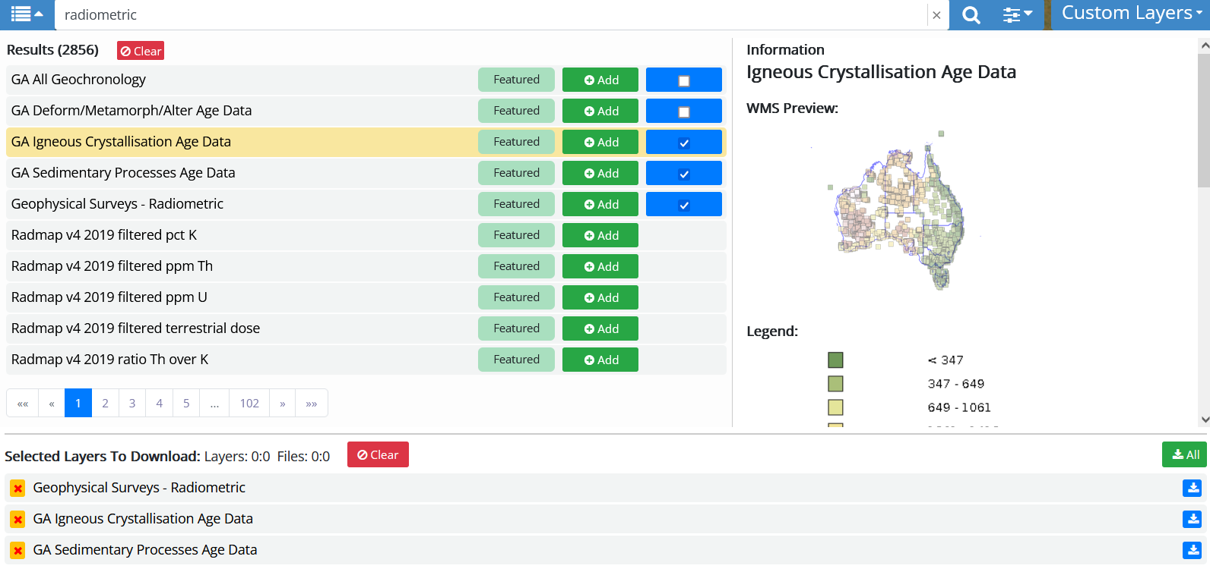

Figure 17: Search and Download Bar

If you click on the  then a “Select Layers to Download” section will open up and you can select layers’ datasets for downloading. They are downloaded via the  button. Multiple layers can be downloaded using the  button.

# Map

The map area is a standard web-based map display: showing a background map with zero or more layers overlaying the map to display selected features. You can zoom in or out by using the mouse wheel and move the map by dragging the mouse around.

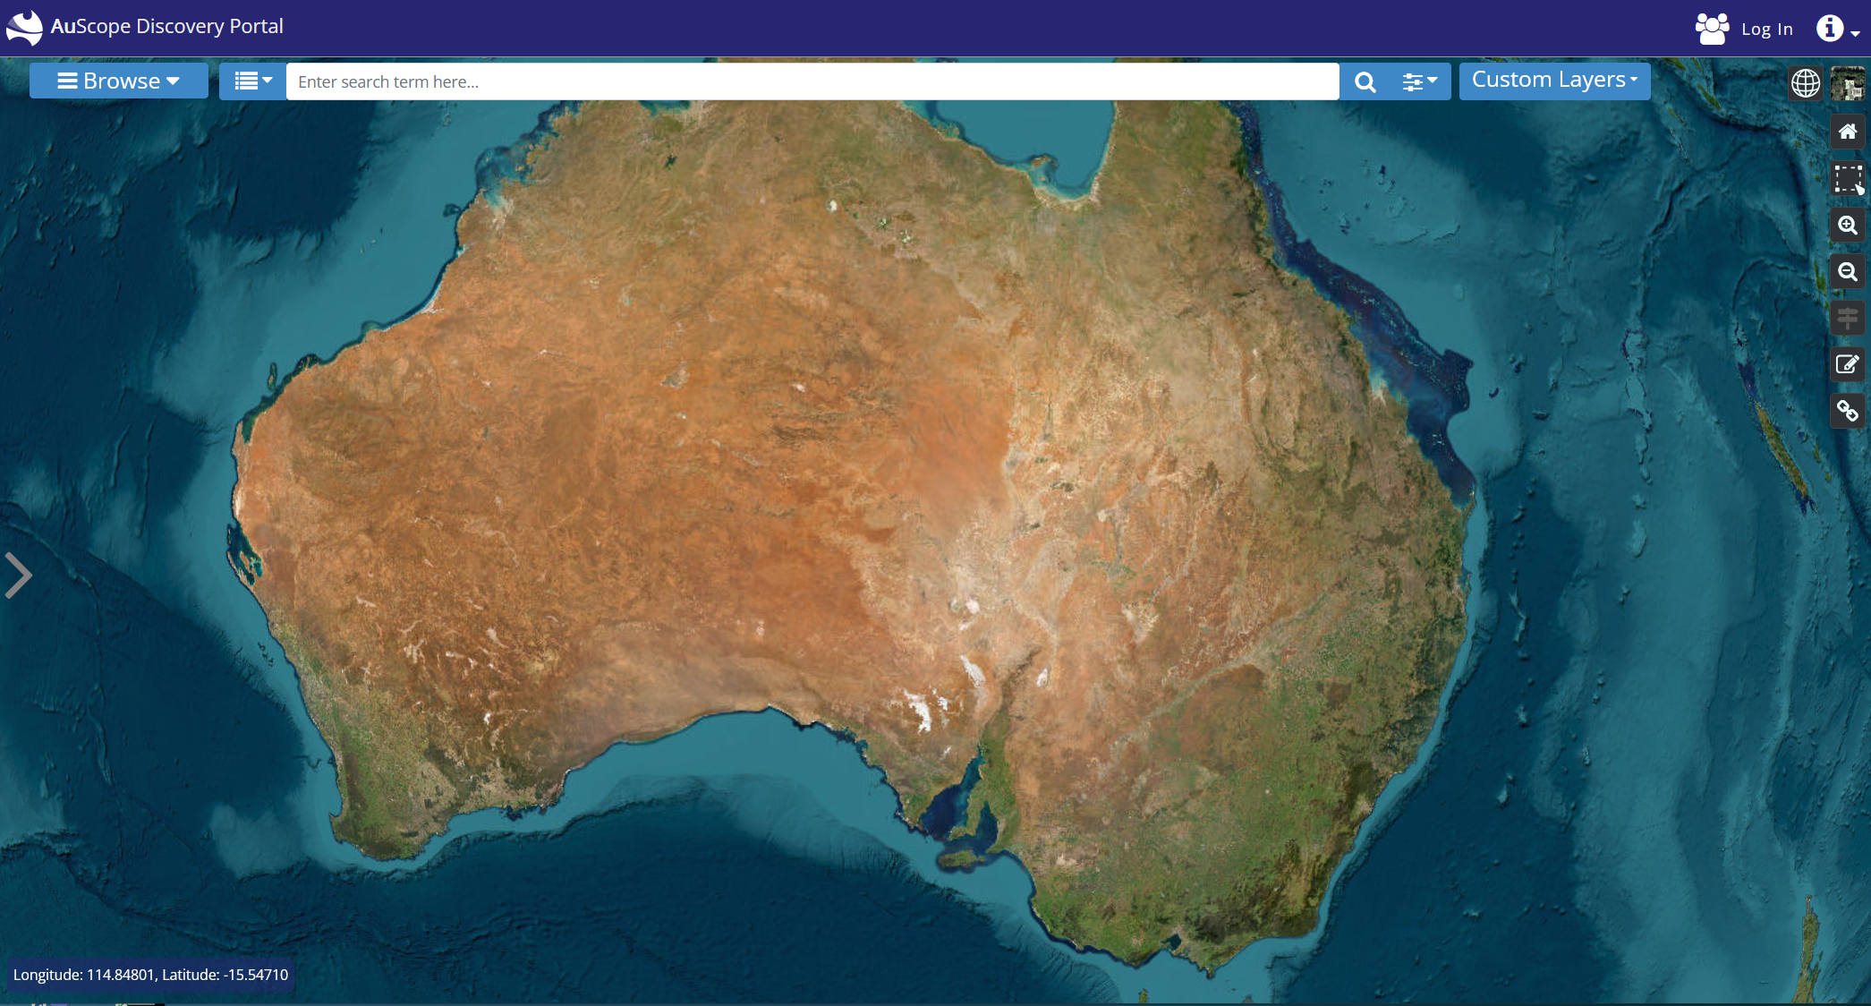

Figure 18: Map of Australia with default “ESRI World Imagery” base map.

# Map Navigation

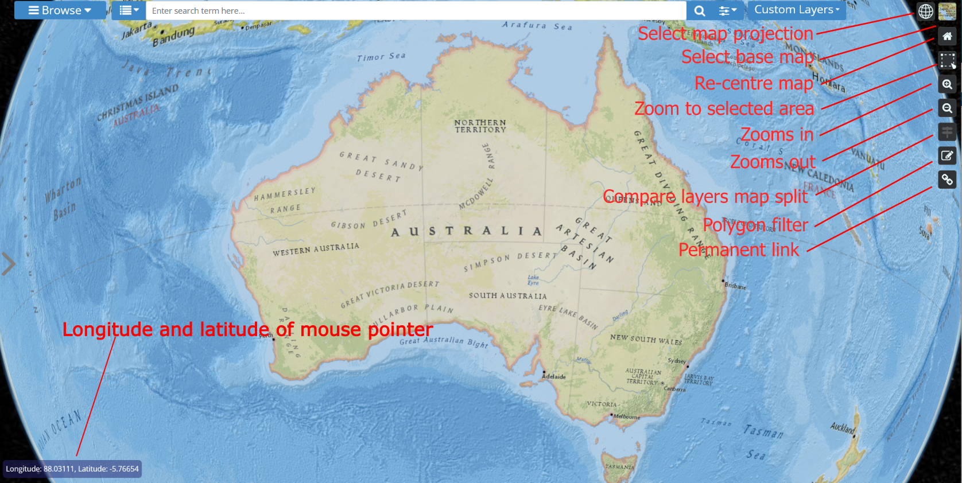

Figure 19: Using the magnify button to zoom to a certain area on the map (ESRI National Geographic)

There are several ways to navigate around the map.

 Using the Zoom button, click the  or  buttons to zoom in or out.

 **Magnify** 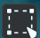 button can be used to zoom to a particular area on the map:

1. Click 
2. Click at the top left-hand corner.
3. Click at the bottom right-hand corner.

* Using the mouse:
  + Move the map: hold the left-mouse button down and move the mouse.
  + Zoom in and out: use the mouse's scroll wheel.

## Split View

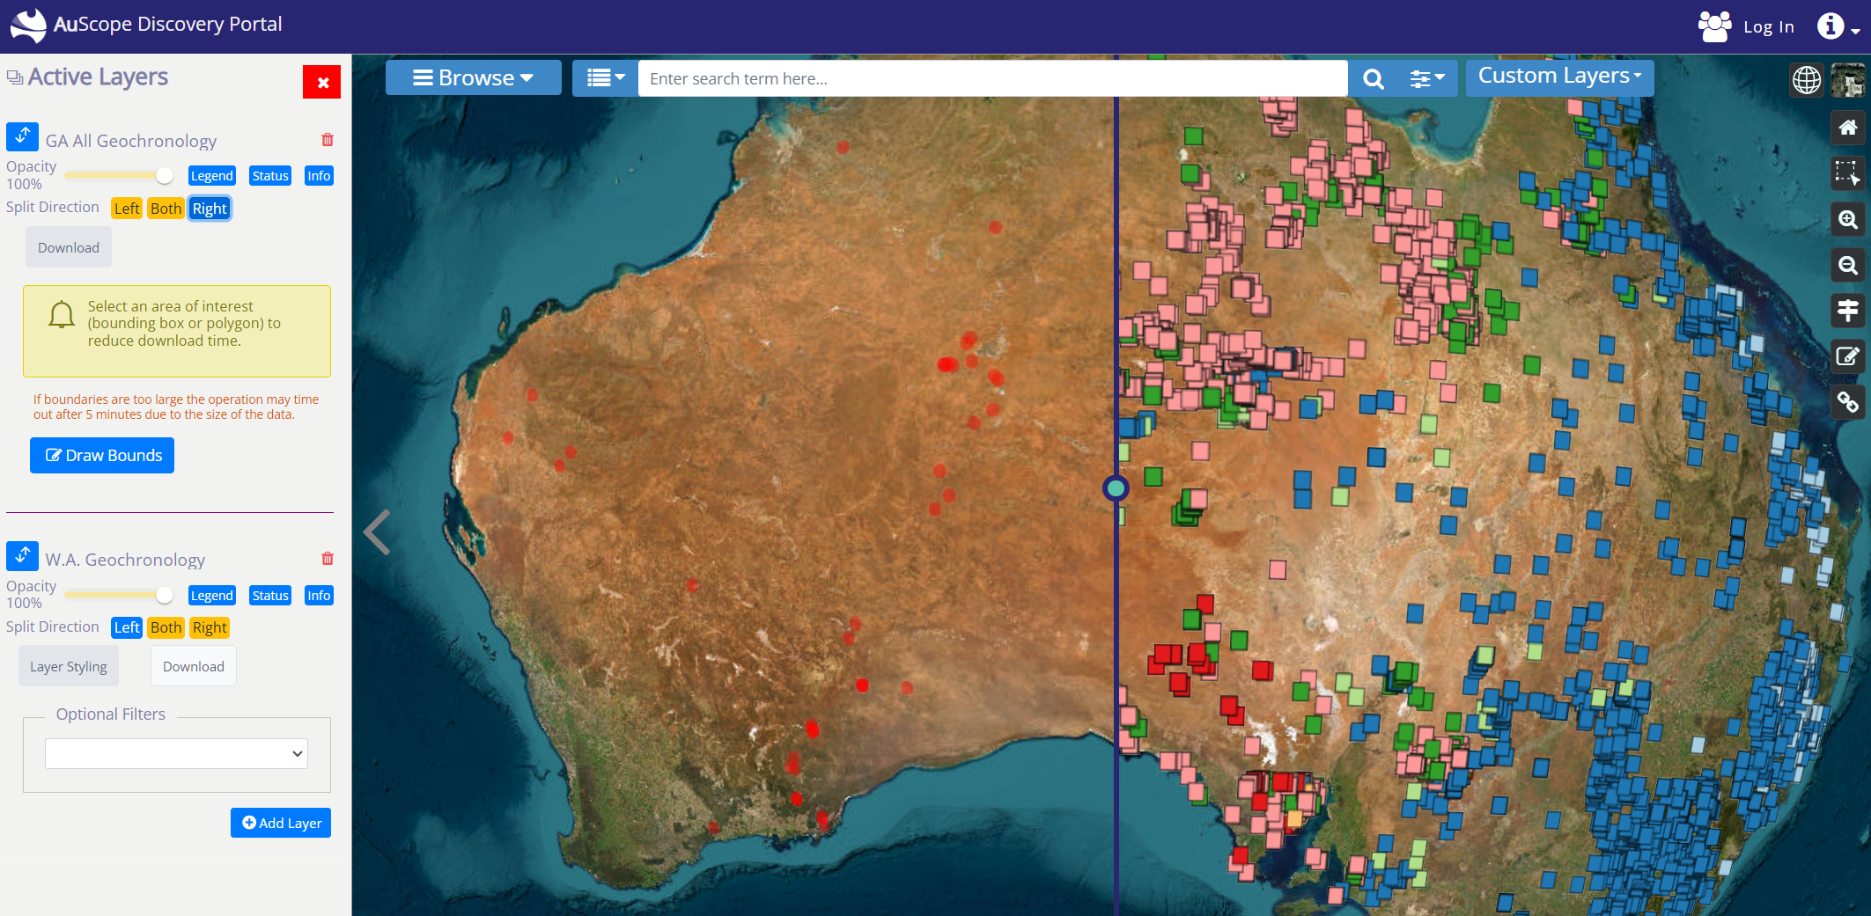

Figure 20: Comparing borehole layers using the split view and the “Left”, “Right” and “Both” buttons.

Once split view mode is enabled via this button, you can load two layers into the “Left”, “Right” or “Both” sides of the map by toggling the buttons in the Active Layers panel (see Figure 20)

## Map Projection

The map projection button has three modes of operation:  or  or 

Using the selector (Figure 21) you can select one:

3D - three dimensional globe view



 2D - two dimensional view

 Columbus View – two dimensional view, but from a distance above the map in 3D space



Figure 21: Selecting map projection.

## Changing the default ESRI World Imagery base map

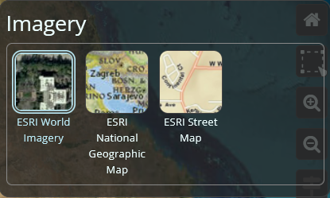

Figure 22: Background map selection.

There are a number of base maps to choose from by clicking on the 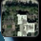 button in the far top right corner of the map.

## Polygon Filter

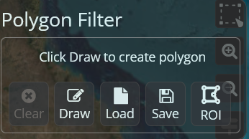

Figure 23: Polygon Filter

Clicking on  reveals the Polygon Filter (Figure 23). The polygon filter is used as a map filter when selecting an exclusive area of the map from which to download data, for example.

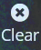 Clears a drawn polygon on the map.

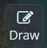 Enables drawing a polygon on the map with the mouse

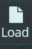 Loads polygon from local filesystem.

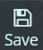 Saves polygon to local filesystem.

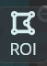 Creates a Region of Interest (ROI). This is a user defined polygon that can be retrieved and utilised in the same way as polygons from other sources. The ROI feature is only enabled when the user is logged in (See Login). The ROI is stored until removed by the user (see Managing ROIs and Permanent Links)

# Custom layers

The  button can be found at the top right-hand side of the window.

## Custom URL

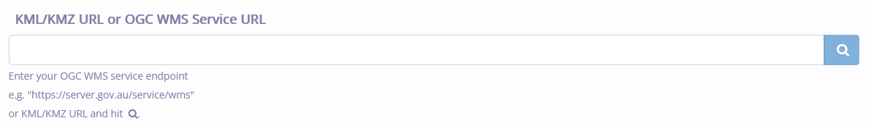

Figure 24: Custom layers.

Custom Layers allows you to add layers from any mapping server in the world. You will need the link (URL) to the web service and enter it into the field in the panel:

Press **Enter** or click on the **magnifying glass **to connect to the service and the portal will query the service's capabilities. In the above figure a flood map provides precipitation and cloud maps amongst other weather data. These capabilities are treated like normal map layer and can be added to the map by clicking on the layer name and clicking the **Add layer to map** button.

|  |  |  |
| --- | --- | --- |
| **Type of data** | **Source Type** | **URL** |
| Flood reports | WMS | [https://afrip.ga.gov.au/geoserver/floods/wms](https://afrip.ga.gov.au/geoserver/floods/wms?request=GetCapabilities&version=1.3.0) |
| WA bike trail | KML | <https://catalogue.data.wa.gov.au/dataset/f950141e-f484-4edd-b6d3-2ead49a4a476/resource/553e646a-0bff-406f-8c45-85c733642f0f/download/munda_biddi_cycle_trail.kml> |
| Power lines | KMZ | <https://d28rz98at9flks.cloudfront.net/83105/ElectricityTransmissionLines_v2.kmz> |

Table 1: Example WMS, KML and KMZ URLs used to demonstrate "Custom Layers" capabilities.

## Custom File

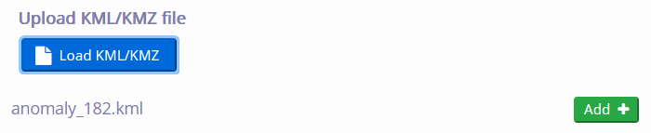

Figure 25: Load a KML or KMZ file onto map.

The user can also load a custom KML or KMZ file onto the map, by clicking on the “Load KML/KMZ” button, selecting a file, then adding the layer via 

# Create a Shareable and Citable Reference

The current state of the portal can be captured in the form of a unique URL. The URL is stored permanently in a database and can be revisited at any time by entering it into your web browser. This is very useful, for example for sharing maps with others or creating a citable reference.

## When not logged in

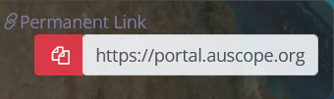

Figure 26: Creating a permanent link when not logged in.

To activate, you click on  at the top left-hand corner of the window. A new unique URL will be generated. To copy it to the system clipboard, click on the  button.

## When logged in

To activate, you click on  at the top left-hand corner of the window.

You can enter a name and an optional description of the link.  
You can also choose whether the link (URL) is accessible to the public.

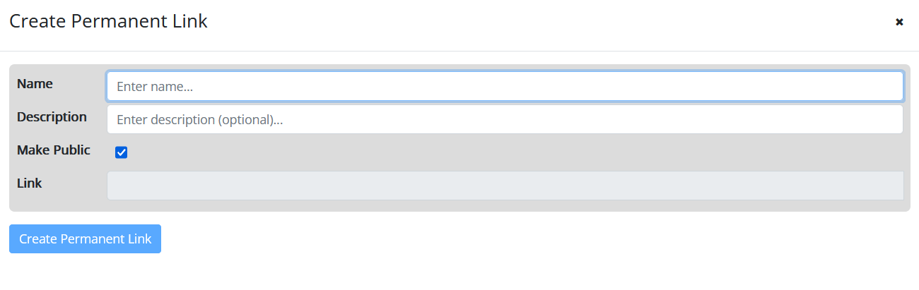

Figure 27: Create a permanent link when logged in.

Hit  to create the link (URL).

To copy it to the system clipboard, click on the  button.

# Login and Bookmarks

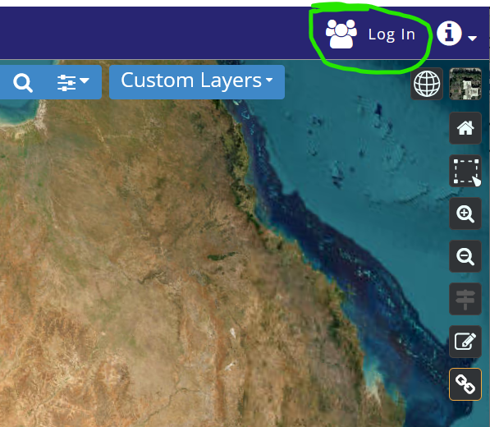

Figure 28: The location of the login button.

You can also login to the portal via AAF or Google or github by clicking on the login button shown above.

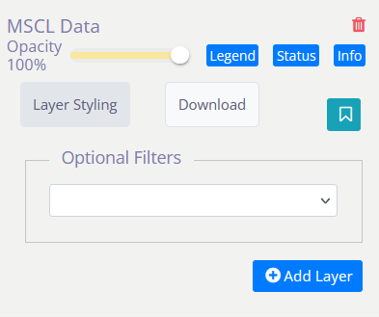

Figure 29: Layers can be bookmarked.

Once logged in, layers can be bookmarked for future reference using the  toggle button. Click on the button a second time to undo the layer bookmark. The bookmarked layers are kept for you and will be available next time you login. Bookmarked layers are shown in Figure 30: Layers in "ASTER Mineral Maps" have been

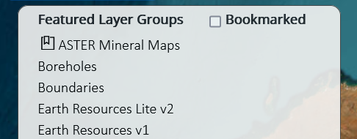

Figure 30: Layers in "ASTER Mineral Maps" have been bookmarked.

Only the bookmarked layers are selectable if the “Bookmarked” tickbox is enabled (see Figure 30)

# Managing ROIs and Permanent Links

When a user is logged-in a dropdown menu is available to manage ROIs and Permanent Links

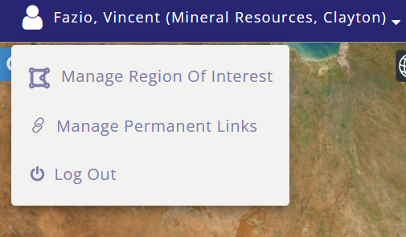

Figure 31: Managing ROIs and Permanent Links

## Managing ROIs

When “Manage Region of Interest” is selected (see Figure 31) a “Region of Interest” dialog box opens (Figure 32)

ROIs can be added to the map via the button and permanently deleted via  (See Figure 32)  
To remove ROI from the map use the 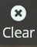 button in the Polygon tool .

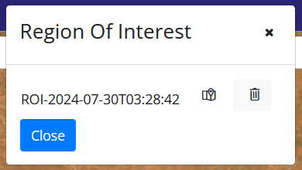

Figure 32: Managing Regions of Interest (ROI)

Permanent links can be:

* Edited using 
* Permanently deleted via 
* Loaded onto the map via 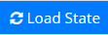

## Managing Access to Shareable URLs

Using the edit function the “Is Public” tickbox can be enabled and this URL will be available to anyone who cares to use it.  
  
Conversely URLs can be made private by unticking the “Is Public” tickbox.

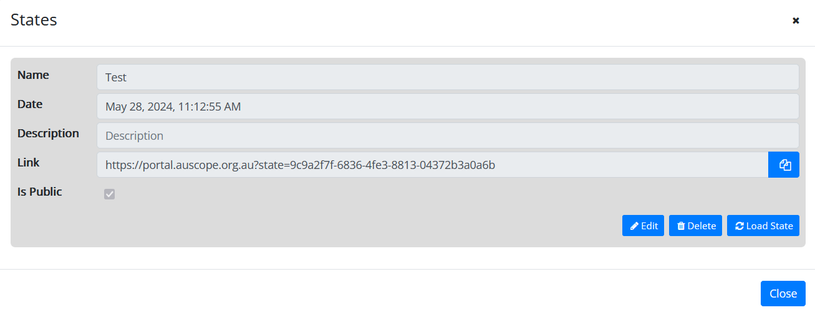

Figure 33: Managing Permanent Links

# Logout

Logout  can be selected via the  button on the top right-hand corner of the page.

# Example 1: NVCL Boreholes

The National Virtual Core Library (NVCL) is a geospatial database holding high resolution pictures of drill samples to help explore the mineralogy and composition of the upper 1-2 km of the Australian continent. The drill samples in the library come from a number of sources including State agencies and industry.

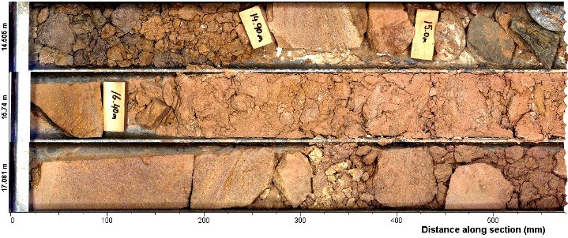

Figure 34: Example core sample.

The following steps display the NVCL data on the portal's map and view the details for one of the core samples. Images of each step are shown below.

1. Select **Browse**
2. Select ***Boreholes***
3. Select the **National Virtual Core Library V2.0** from the list of layers.
4. Click on the **Add layer** button to draw the data points on the map. You may also filter the data to a subset using the options in the filter panel (remember to select the filters *before* adding the layer to the map).
5. Click on a red circular marker on the map, a popup dialog box will appear.
6. Click on borehole id to open up details panel.
7. Click on **Image** tab.
8. This shows thumbnail images of the borehole cores. Next, click on the **Scalar** tab.
9. This shows all datasets obtained from measurements of the core samples. For example, infra-red spectroscopy measurements of the samples. You can click on the "Definition" link to get more information about what kind of sample was taken. The next action is to select a dataset or more by clicking in the tickboxes.
10. Click on the graph icon to display a graph of the selected mineral measurements.

## NVCL Boreholes: Steps 1, 2, 3 and 4

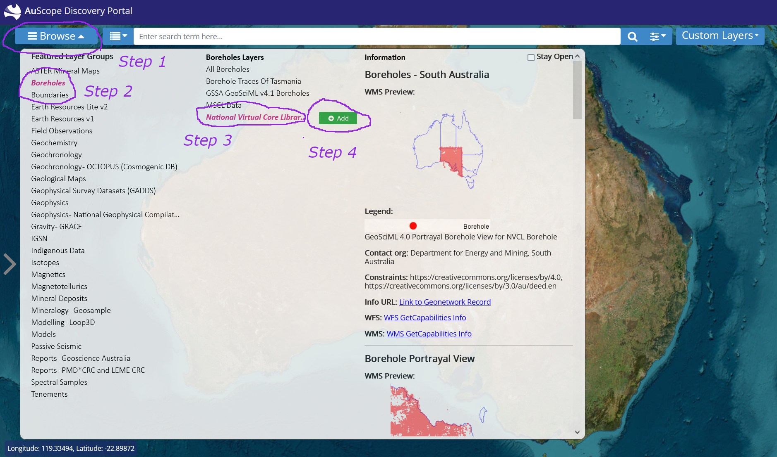

Figure 35: NVCL Boreholes: Steps 1, 2, 3 and 4

## NVCL Boreholes: Step 6

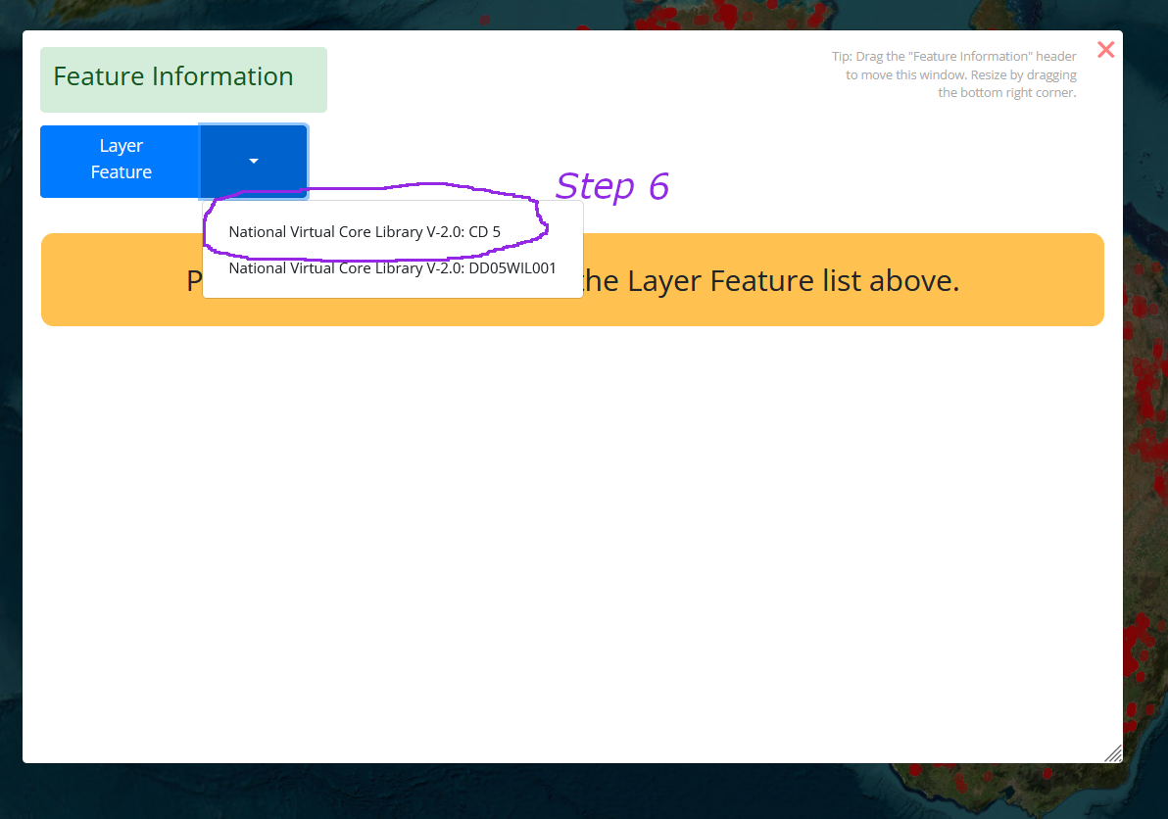

Figure 36: NVCL Boreholes: Step 6: Select a borehole.

## NVCL Boreholes: Step 7

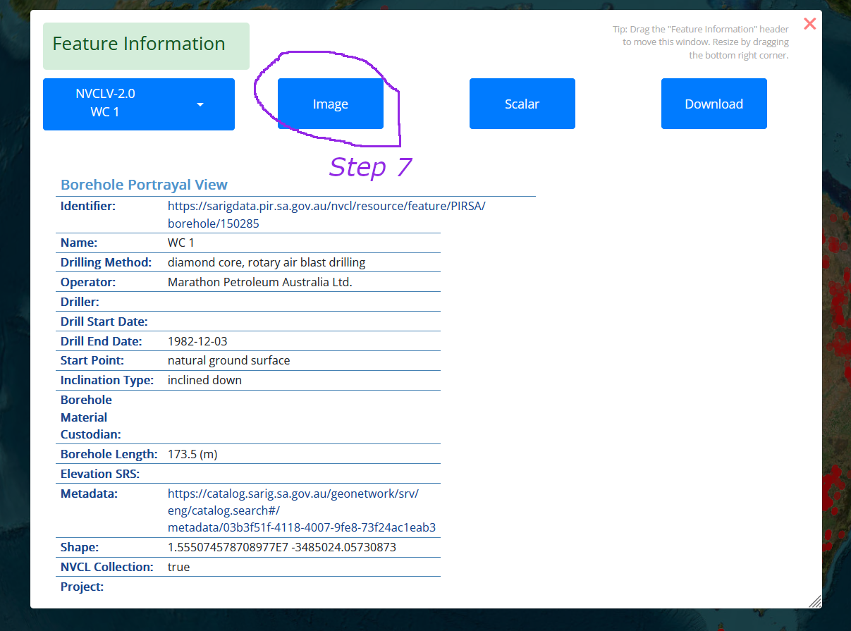

Figure 37: NVCL Boreholes: Step 7: click on Image tab.

## NVCL Boreholes: Step 8

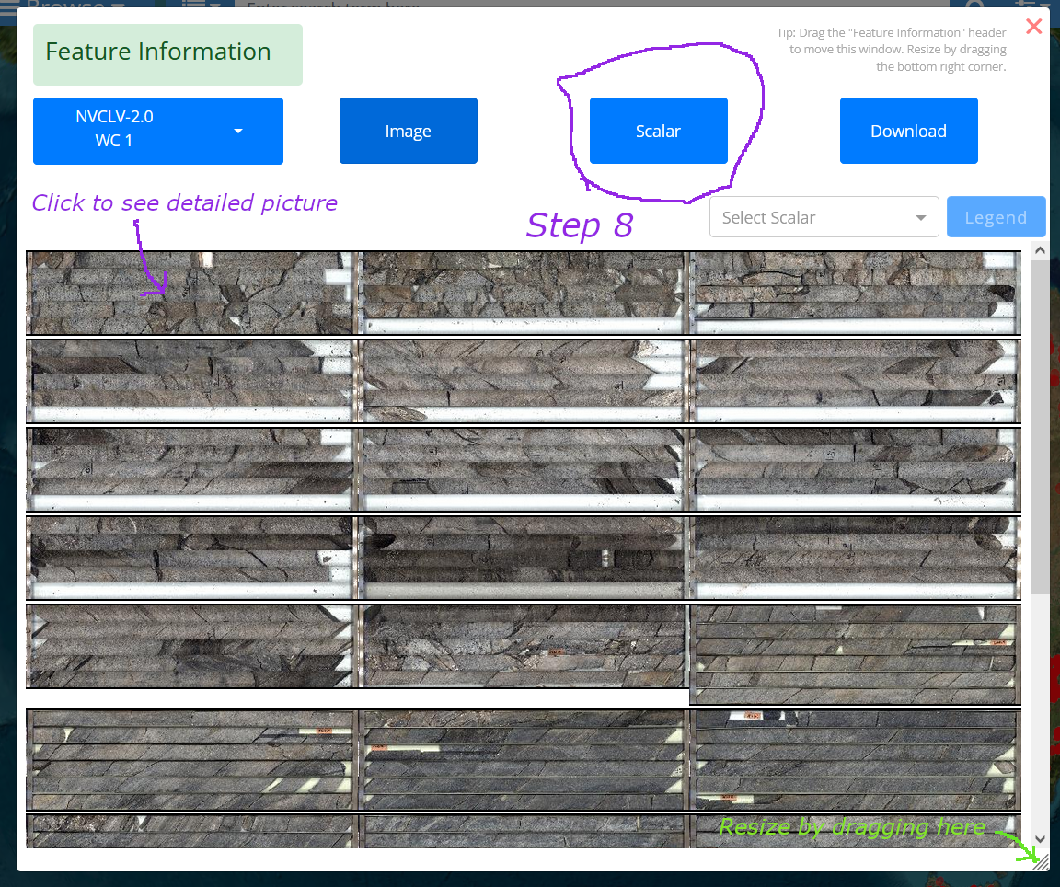

Figure 38: NVCL Boreholes: Step 7: Click Scalar tab.

## NVCL Borehole Service View

In Step 8 above, you can click on a thumbnail in the AuScope portal and get a high-resolution image of the borehole drill samples from the relevant NVCL service website.

At the left- and right-hand side of the image there are arrows which can be used to view borehole images at lower and higher depths (see below).

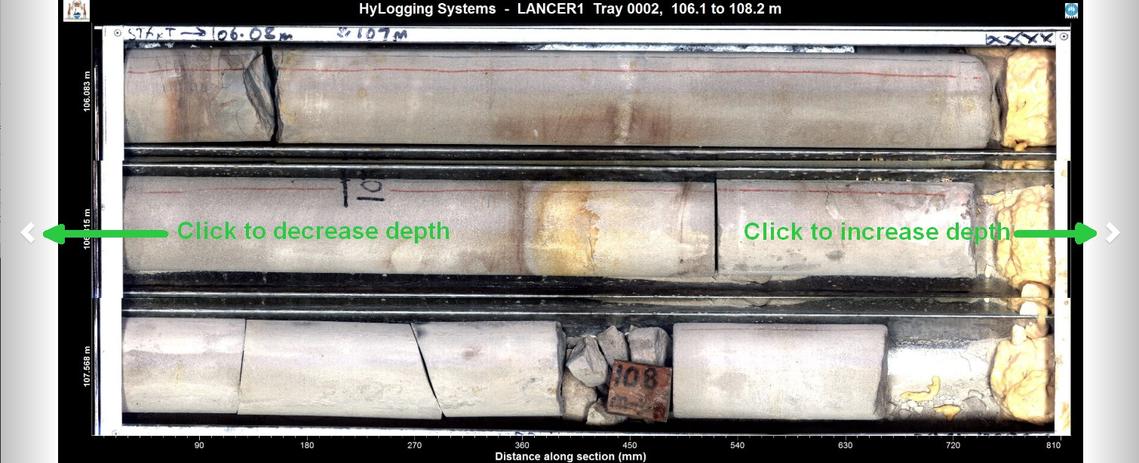

Figure 39: NVCL Borehole Service View

If you *double click* on this picture, you can see spectral data plots taken from the samples, as depicted below.

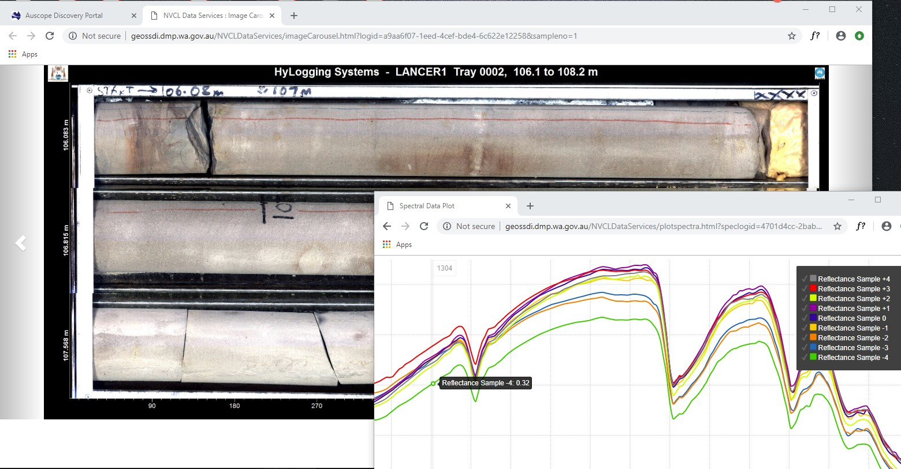

Figure 40: NVCL Borehole Service detailed image and spectral data plots.

## NVCL Boreholes: Steps 9 and 10

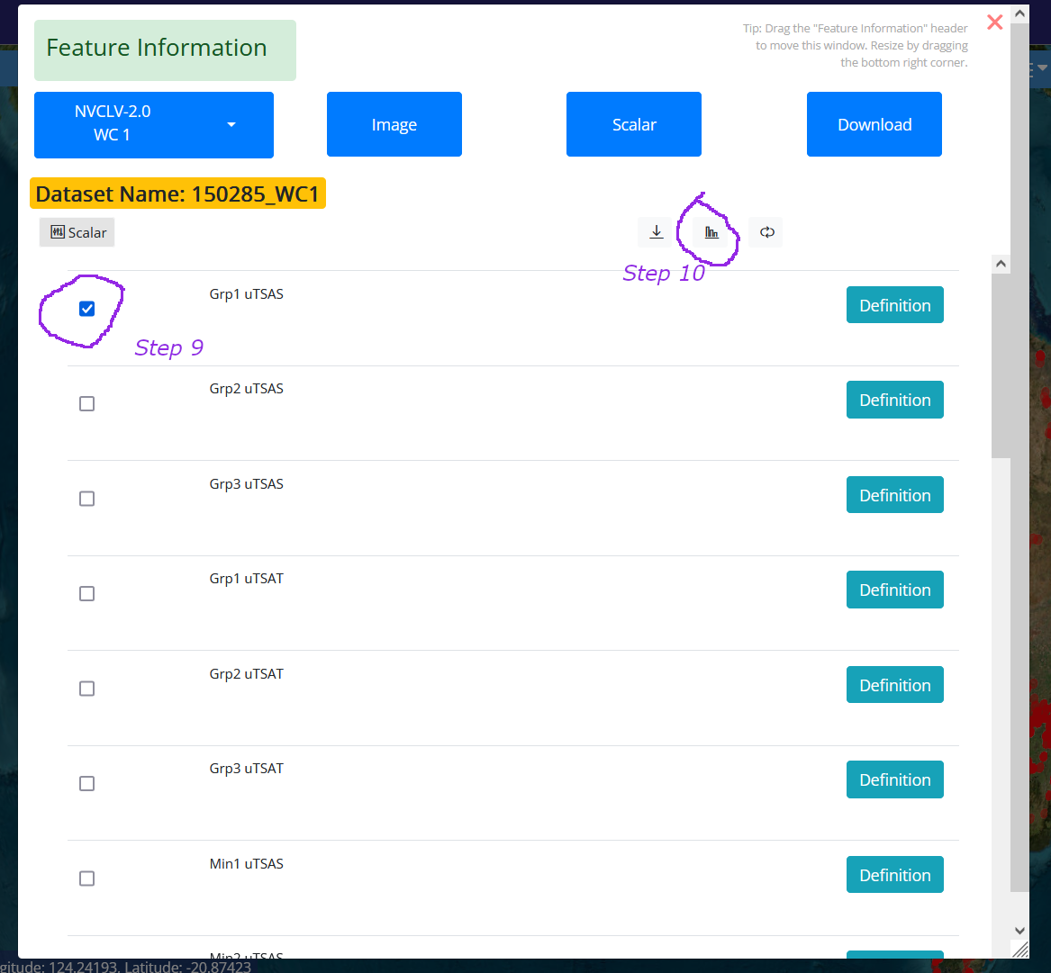

Figure 41: NVCL Boreholes: Steps 9 and 10

A typical graph of the mineral measurements is shown below. A user can hold the mouse pointer over a point in the graph and the depth and sample count at that point will be displayed, e.g.

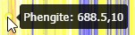

Figure 42: Depth and sample count at a point.

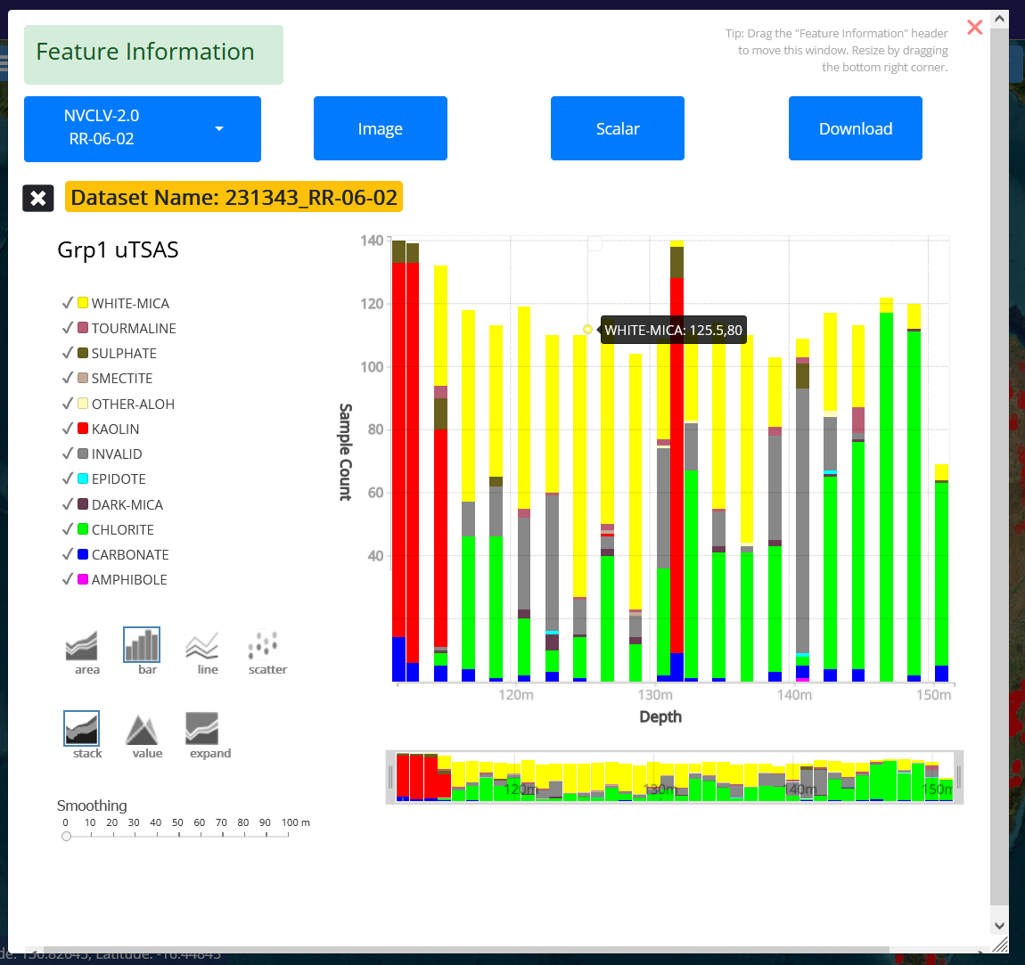

Figure 43: NVCL Boreholes: Graph of borehole minerals.

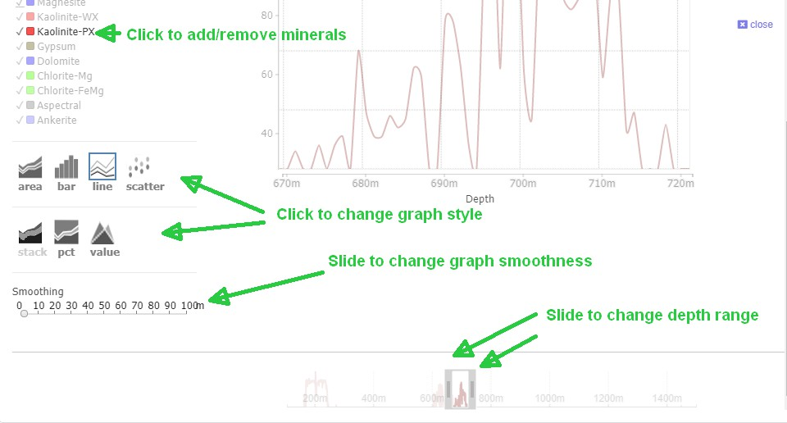

Figure 44: NVCL Boreholes: Details of graph controls.

# Example 2: Download an NVCL TSG Dataset

To download an NVCL TSG Dataset:

1. Click **Browse,** select ***Boreholes.***

Select the **National Virtual Core Library V2.0** from the list of layers.

Click “Add layer”

Click on **Select Filter** dropdown and select **Name**.

Enter a name (e.g. Shittim).

Click **Select Filter** dropdown and select **Provider**.

Click on **Tasmania** (for example).

Click the blue **Add Layer** button to display boreholes on the map.

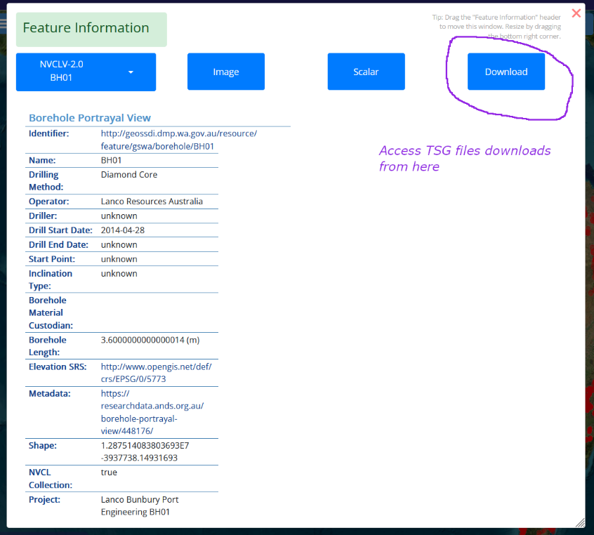

Figure 45: Click on "Download" tab.

1. Click a red borehole point on the map.

A popup window will open up.

Select a borehole if necessary.

Click the **Download** tab.  
  
Either:

1. Click on  button.  
   The file will be immediately downloaded via your browser.  
     
   OR
2. The TSG file cannot be found in the cache, so enter your email address.

Click   
  
You can click on 

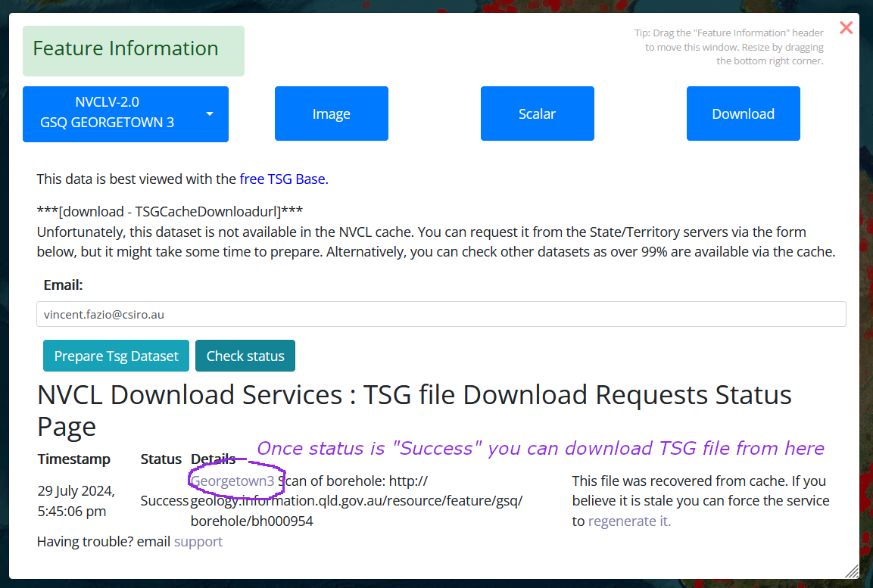

Figure 46: Click on Prepare Tsg Dataset button.

# Example 3: Filter By Geological Province

## Steps 1, 2 & 3: Filtering by name, add geological province layer.

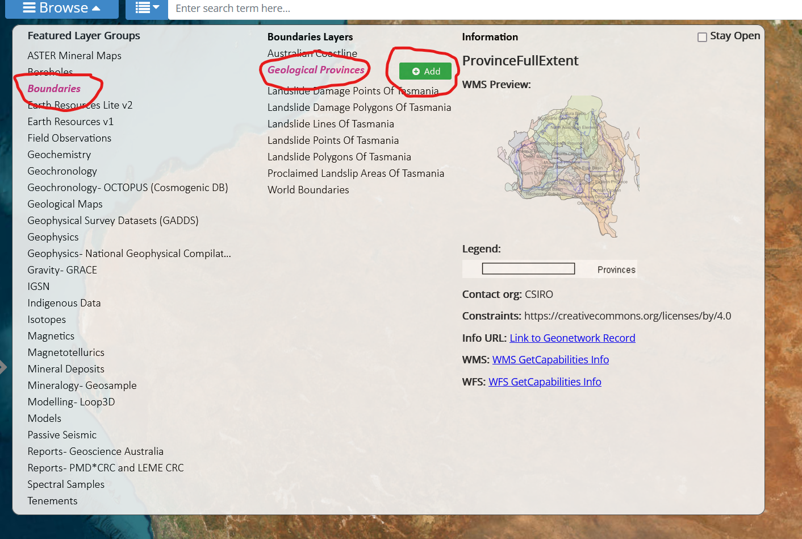

Figure 47: Step 1: Add geological province layer.

Step 1: Click on “Browse” to open browse panel. Click in “Boundaries”, then “Geological Provinces”, then “Add” to add the Geological Provinces layer.

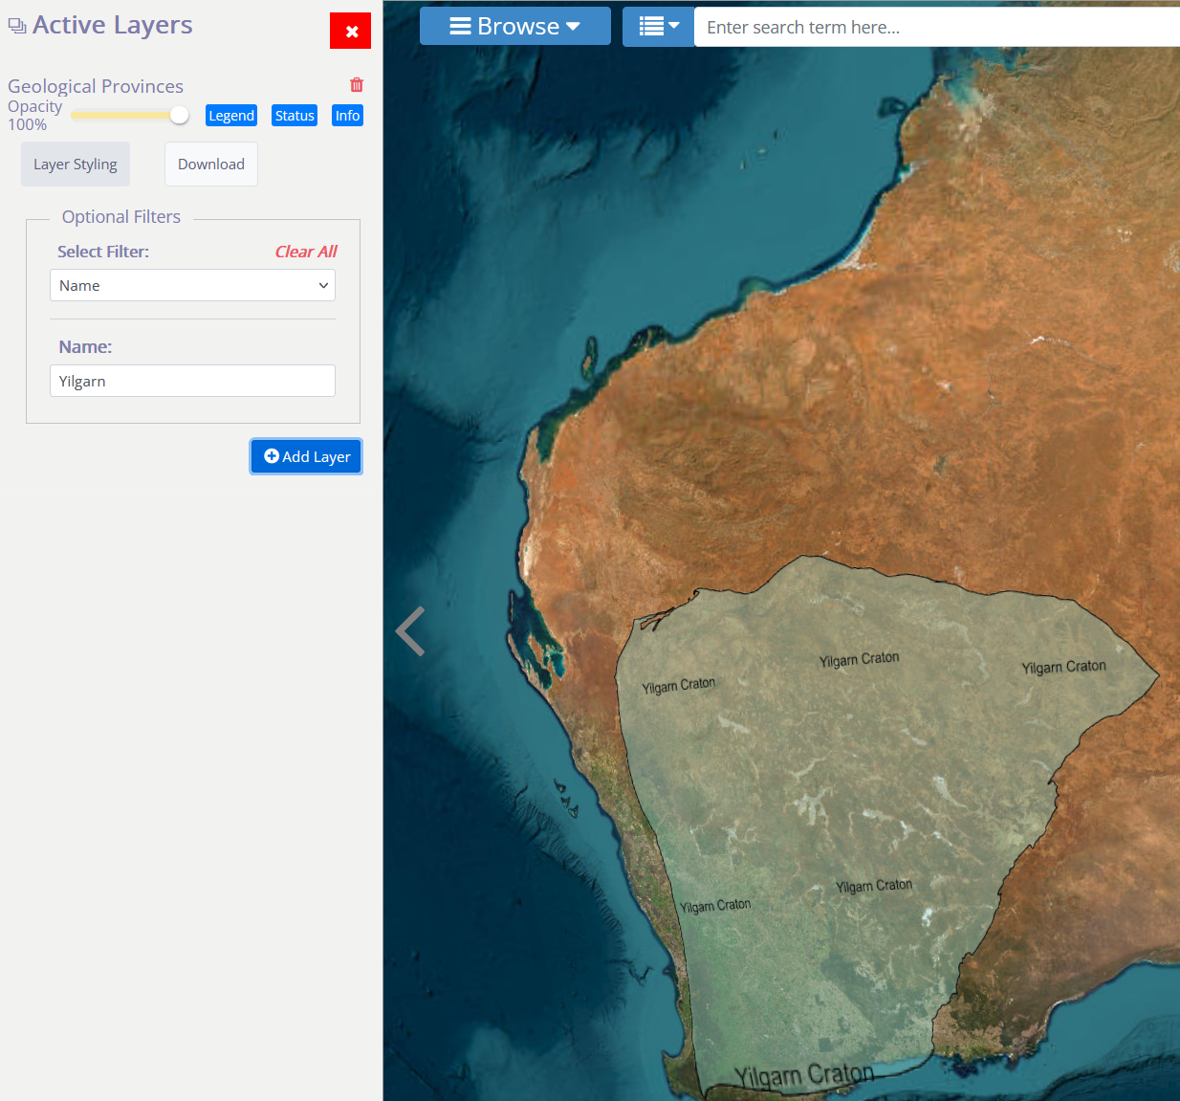

Figure 48: Step 2: Filter by name: "Yilgarn.”

Step 2: Click on “Select filter”, select filtering by name, type in “Yilgarn”, hit “Add Layer” button.

Step 3: Click on green Yilgarn layer on map, a popup will appear.

## Step 4: Copying to clipboard.

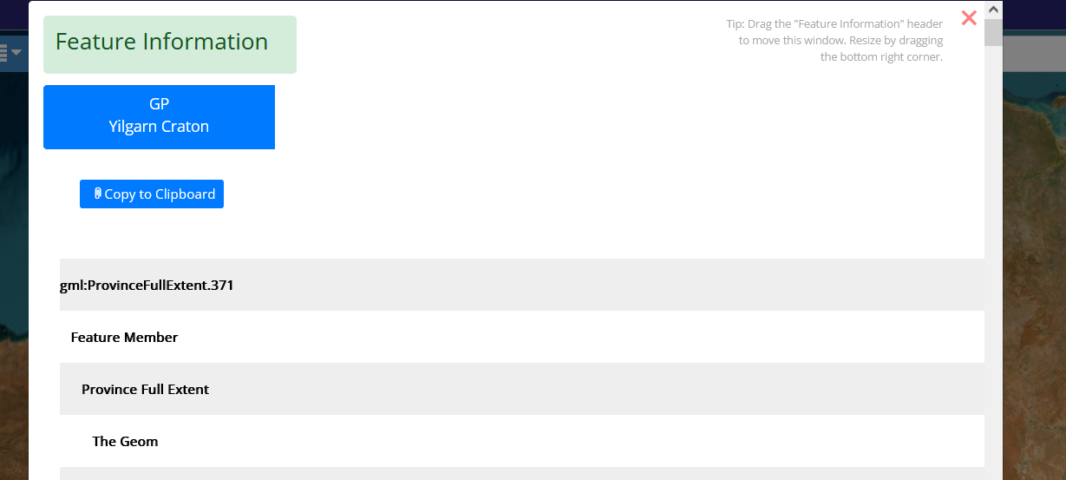

Figure 49: Step 4: Click on “Copy to Clipboard.”

Step 4: Click on “Copy to clipboard" button, close dialog box.

## Step 5: Add NVCL borehole layer.

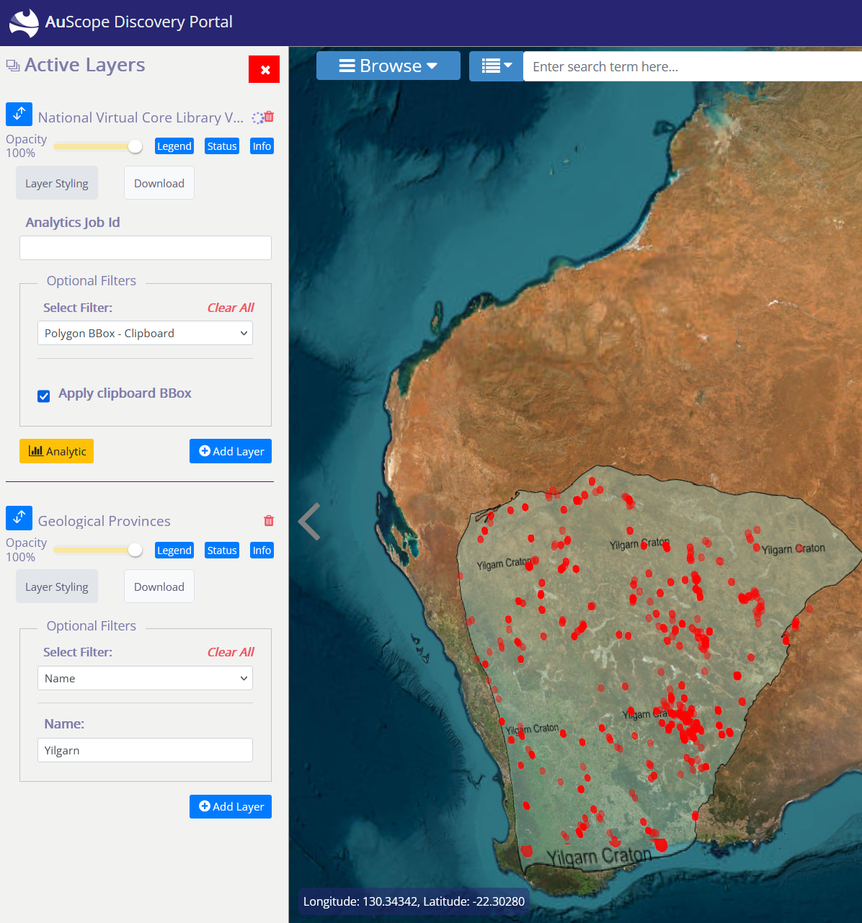

Figure 50: Step 5 & 6, National Virtual Core Library V2.0” layer and filter by geological province.

Step 5**:** Using Browse Panel, Add “National Virtual Core Library V2.0” layer, in the “Boreholes” category  
Step 6: In the Active Layers, under “Select Filter”, select the "Polygon BBox - Clipboard" filter, making sure "Apply clipboard BBox" checkbox is ticked, then hit “Add Layer” button

# Glossary

|  |  |
| --- | --- |
| **Term** | **Meaning** |
| [CSW](https://en.wikipedia.org/wiki/Catalog_Service_for_the_Web) | Catalog Service for the Web (Catalog Service – Web) |
| [GA](https://www.ga.gov.au/) | Geoscience Australia |
| [GML](https://en.wikipedia.org/wiki/Geography_Markup_Language) | Geography Markup Language |
| [OGC](https://en.wikipedia.org/wiki/Open_Geospatial_Consortium) | Open Geospatial Consortium |
| ROI | Region of Interest |
| [SRS](https://en.wikipedia.org/wiki/Spatial_reference_system) | Spatial Reference System |
| [URL](https://en.wikipedia.org/wiki/URL) | Universal Resource Locator |
| [WCS](https://en.wikipedia.org/wiki/Web_Coverage_Service) | Web Coverage Service |
| [WFS](https://en.wikipedia.org/wiki/Web_Feature_Service) | Web Feature Service |
| [WMS](https://en.wikipedia.org/wiki/Web_Map_Service) | Web Mapping Service |
| [XML](https://en.wikipedia.org/wiki/Xml) | Extensible Markup Language |